**Practical 1**

**Objective:** Consider a scenario:

A developer develops the simple “SMS App”. The app functionality is as follows

a. Simple SMS functionality.

b. When you open the app it asks you your “age”.

c. If “age” is less than 16, then the app will ask you your parent’s number.

d. If you send more than 10 messages the report goes to your parent. Test this app. Write all the possible test cases for this app.

**Prerequisites:** Candidate should familiar with how to use controls and basic operations in android application environment.

**Steps/Process**

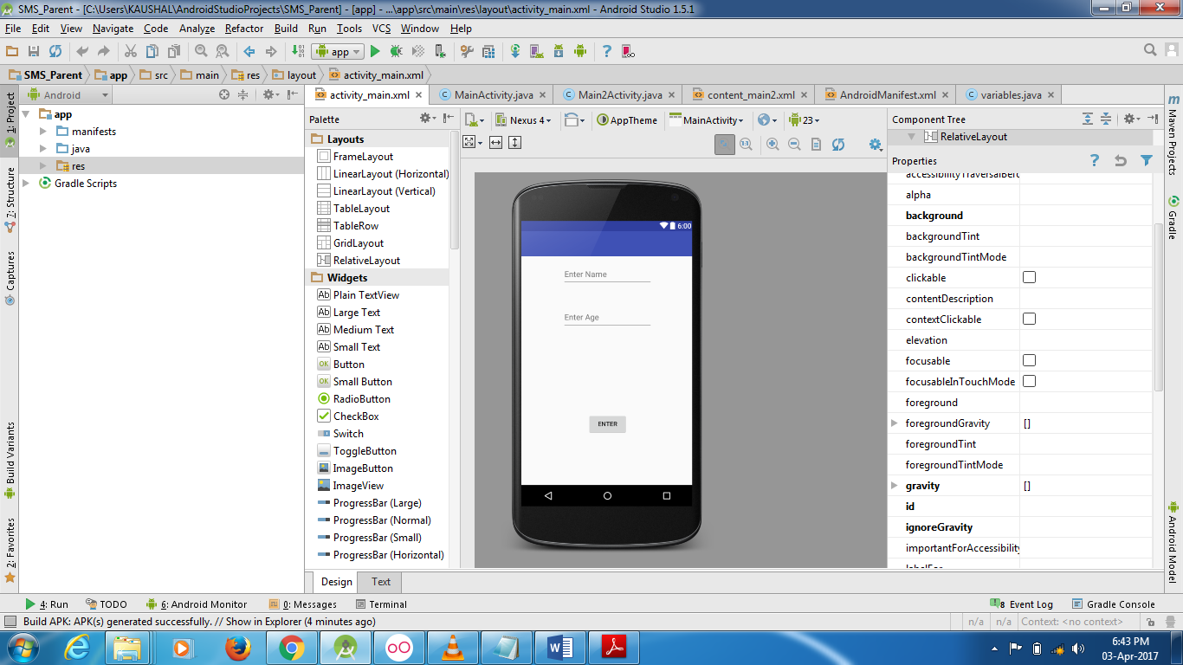

**Main Activity file (xml)**

*<?***xml version="1.0" encoding="utf-8"***?>*<**RelativeLayout xmlns:android="http://schemas.android.com/apk/res/android"  
 xmlns:tools="http://schemas.android.com/tools"  
 android:layout_width="match_parent"  
 android:layout_height="match_parent"  
 android:paddingBottom="@dimen/activity_vertical_margin"  
 android:paddingLeft="@dimen/activity_horizontal_margin"  
 android:paddingRight="@dimen/activity_horizontal_margin"  
 android:paddingTop="@dimen/activity_vertical_margin"  
 tools:context="com.example.kaushal.sms_parent.MainActivity"**>  
  
 <**EditText  
 android:layout_width="wrap_content"  
 android:layout_height="wrap_content"  
 android:id="@+id/editText"  
 android:height="50dp"  
 android:width="200dp"  
 android:hint="Enter Name"  
 android:layout_alignParentTop="true"  
 android:layout_centerHorizontal="true"** />  
  
 <**EditText  
 android:layout_width="wrap_content"  
 android:layout_height="wrap_content"  
 android:id="@+id/editText2"  
 android:height="50dp"  
 android:width="200dp"  
 android:layout_below="@+id/editText"  
 android:layout_centerHorizontal="true"  
 android:layout_marginTop="46dp"  
 android:hint="Enter Age"** />  
  
 <**EditText  
 android:layout_width="wrap_content"  
 android:layout_height="wrap_content"  
 android:id="@+id/editText3"  
 android:layout_centerVertical="true"  
 android:layout_alignEnd="@+id/editText2"  
 android:width="200dp"  
 android:height="50dp"  
 android:hint="Enter Parent Number"  
 android:visibility="gone"** />  
  
 <**Button  
 android:layout_width="wrap_content"  
 android:layout_height="wrap_content"  
 android:text="Enter"  
 android:id="@+id/button"  
 android:onClick="transferdata"  
 android:layout_alignParentBottom="true"  
 android:layout_centerHorizontal="true"  
 android:layout_marginBottom="96dp"** />  
</**RelativeLayout**>

**Manifest File**

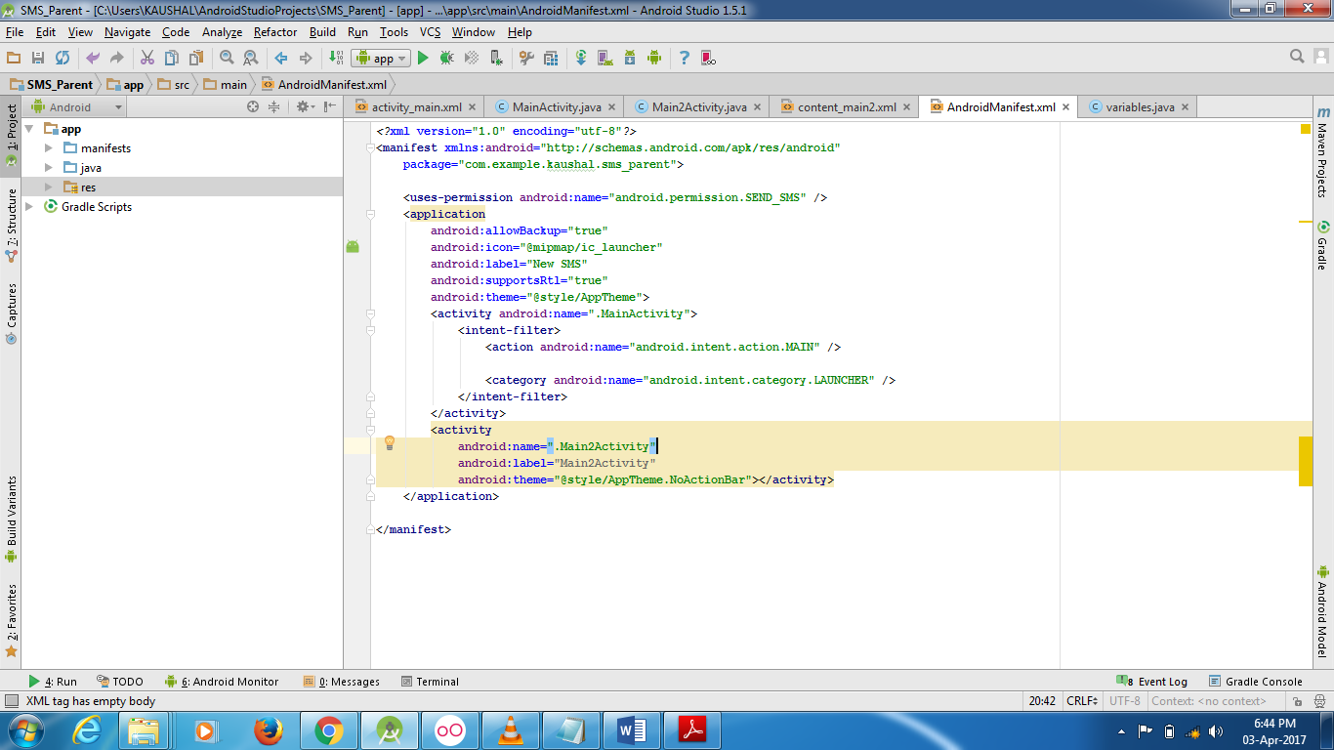

**Java File**

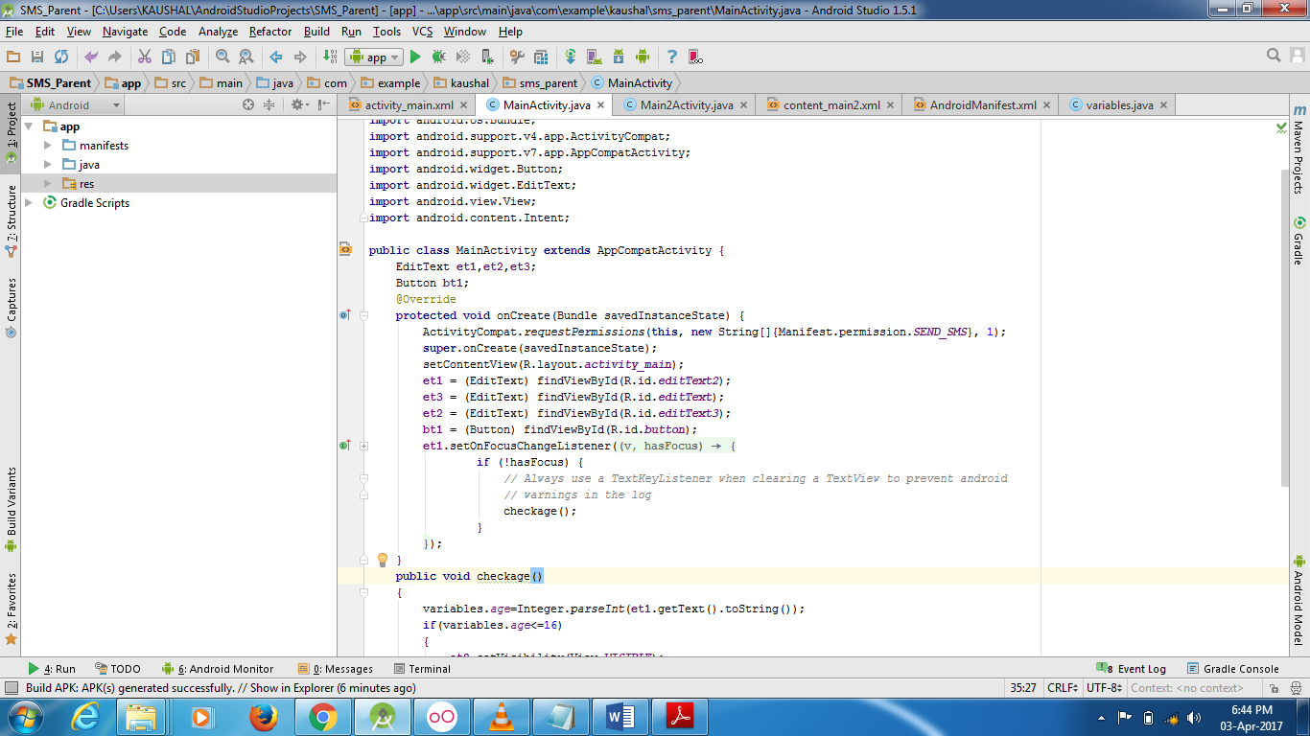

**Java Code:**

**package** com.example.kaushal.sms_parent;  
  
**import** android.Manifest;  
**import** android.os.Bundle;  
**import** android.support.v4.app.ActivityCompat;  
**import** android.support.v7.app.AppCompatActivity;  
**import** android.widget.Button;  
**import** android.widget.EditText;  
**import** android.view.View;  
**import** android.content.Intent;  
  
**public class** MainActivity **extends** AppCompatActivity {  
 EditText **et1**,**et2**,**et3**;  
 Button **bt1**;  
 @Override  
 **protected void** onCreate(Bundle savedInstanceState) {  
 ActivityCompat.*requestPermissions*(**this**, **new** String[]{Manifest.permission.***SEND_SMS***}, 1);  
 **super**.onCreate(savedInstanceState);  
 setContentView(R.layout.activity_main);  
 **et1** = (EditText) findViewById(R.id.***editText2***);  
 **et3** = (EditText) findViewById(R.id.***editText***);  
 **et2** = (EditText) findViewById(R.id.***editText3***);  
 **bt1** = (Button) findViewById(R.id.***button***);  
 **et1**.setOnFocusChangeListener(**new** View.OnFocusChangeListener() {  
 @Override  
 **public void** onFocusChange(View v, **boolean** hasFocus) {  
 **if** (!hasFocus) {  
 *// Always use a TextKeyListener when clearing a TextView to prevent android  
 // warnings in the log* checkage();  
 }  
 }  
 });  
 }  
 **public void** checkage()  
 {  
 variables.*age*=Integer.*parseInt*(**et1**.getText().toString());  
 **if**(variables.*age*<=16)  
 {  
 **et2**.setVisibility(View.***VISIBLE***);  
 }  
 }  
 **public void** transferdata(View v)  
 {  
 variables.*name*=**et3**.getText().toString();  
 variables.*age*=Integer.*parseInt*(**et1**.getText().toString());  
 variables.*parentno*=**et2**.getText().toString();  
  
 startActivity(**new** Intent(**this**,Main2Activity.**class**));  
 }  
}

**Second Activity Page**

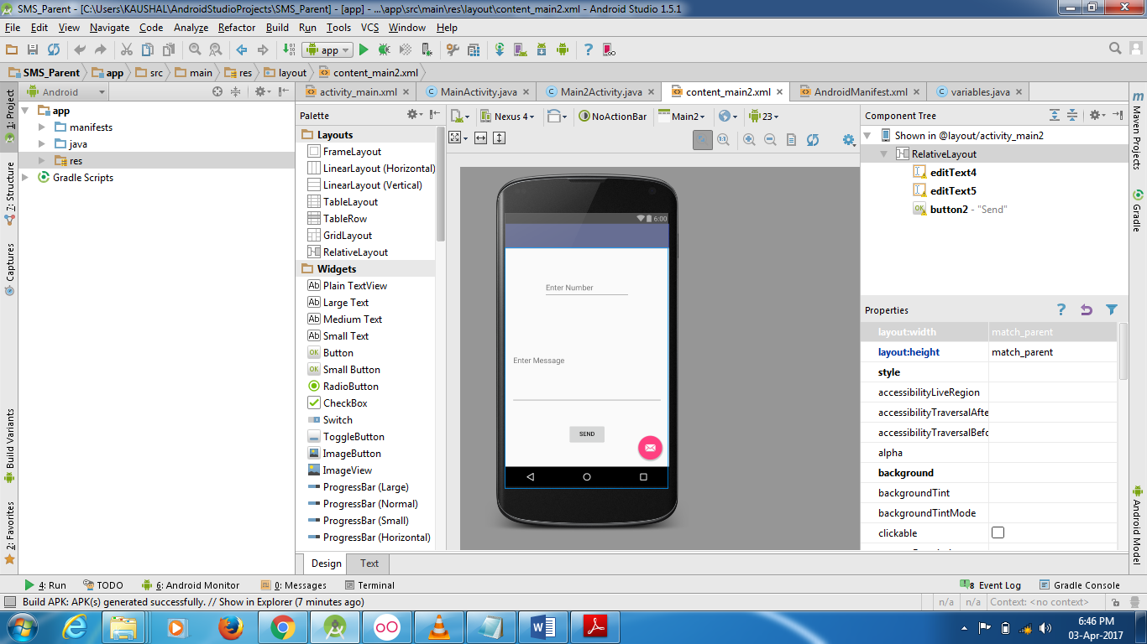

**Main Activity file (xml)**

*<?***xml version="1.0" encoding="utf-8"***?>*<**RelativeLayout xmlns:android="http://schemas.android.com/apk/res/android"  
 xmlns:app="http://schemas.android.com/apk/res-auto"  
 xmlns:tools="http://schemas.android.com/tools"  
 android:layout_width="match_parent"  
 android:layout_height="match_parent"  
 android:paddingBottom="@dimen/activity_vertical_margin"  
 android:paddingLeft="@dimen/activity_horizontal_margin"  
 android:paddingRight="@dimen/activity_horizontal_margin"  
 android:paddingTop="@dimen/activity_vertical_margin"  
 app:layout_behavior="@string/appbar_scrolling_view_behavior"  
 tools:context="com.example.kaushal.sms_parent.Main2Activity"  
 tools:showIn="@layout/activity_main2"**>  
  
 <**EditText  
 android:layout_width="wrap_content"  
 android:layout_height="wrap_content"  
 android:id="@+id/editText4"  
 android:layout_alignParentTop="true"  
 android:layout_centerHorizontal="true"  
 android:layout_marginTop="53dp"  
 android:hint="Enter Number"  
 android:height="50dp"  
 android:width="200dp"** />  
  
 <**EditText  
 android:layout_width="wrap_content"  
 android:layout_height="wrap_content"  
 android:inputType="textMultiLine"  
 android:ems="10"  
 android:id="@+id/editText5"  
 android:layout_below="@+id/editText4"  
 android:layout_alignParentStart="true"  
 android:layout_marginTop="45dp"  
 android:layout_alignParentEnd="true"  
 android:height="200dp"  
 android:hint="Enter Message"** />  
  
 <**Button  
 android:layout_width="wrap_content"  
 android:layout_height="wrap_content"  
 android:text="Send"  
 android:id="@+id/button2"  
 android:layout_marginTop="47dp"  
 android:layout_below="@+id/editText5"  
 android:layout_centerHorizontal="true"  
 android:onClick="sendMessage"** />  
</**RelativeLayout**>

**Java File**

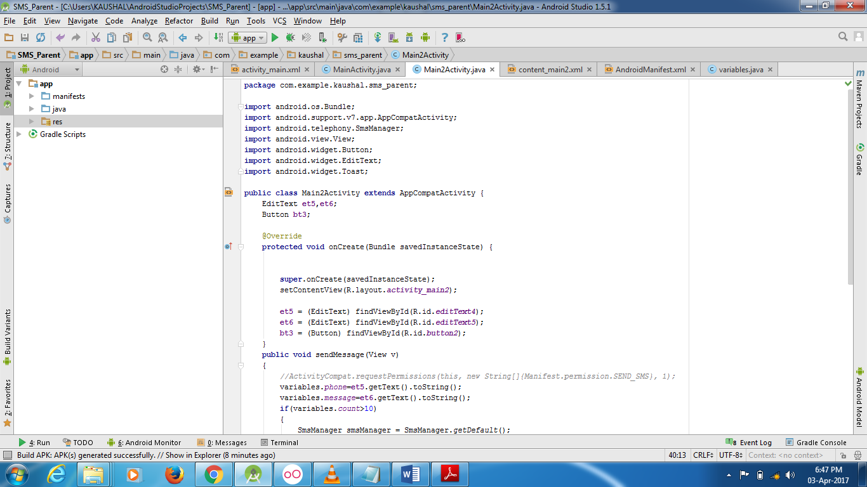

**Java Code:**

**package** com.example.kaushal.sms_parent;  
  
**import** android.os.Bundle;  
**import** android.support.v7.app.AppCompatActivity;  
**import** android.telephony.SmsManager;  
**import** android.view.View;  
**import** android.widget.Button;  
**import** android.widget.EditText;  
**import** android.widget.Toast;  
  
**public class** Main2Activity **extends** AppCompatActivity {  
 EditText **et5**,**et6**;  
 Button **bt3**;  
  
 @Override  
 **protected void** onCreate(Bundle savedInstanceState) {  
  
  
 **super**.onCreate(savedInstanceState);  
 setContentView(R.layout.***activity_main2***);  
  
 **et5** = (EditText) findViewById(R.id.***editText4***);  
 **et6** = (EditText) findViewById(R.id.***editText5***);  
 **bt3** = (Button) findViewById(R.id.***button2***);  
 }  
 **public void** sendMessage(View v)  
 {  
 *//ActivityCompat.requestPermissions(this, new String[]{Manifest.permission.SEND_SMS}, 1);* variables.*phone*=**et5**.getText().toString();  
 variables.*message*=**et6**.getText().toString();  
 **if**(variables.*count*>10)  
 {  
 SmsManager smsManager = SmsManager.*getDefault*();  
 smsManager.sendTextMessage(variables.*parentno*, **null**, variables.*message*, **null**, **null**);  
 variables.*count*=0;  
 Toast.*makeText*(getApplicationContext(), **"Limit exceeded.... Sms is sending to ur parent!"**, Toast.***LENGTH_LONG***).show();  
 **et5**.setText(**""**);  
 **et6**.setText(**""**);  
 }  
 **else** {  
 SmsManager smsManager = SmsManager.*getDefault*();  
 smsManager.sendTextMessage(variables.*phone*, **null**, variables.*message*, **null**, **null**);  
 Toast.*makeText*(getApplicationContext(), **"SMS Sent!"**, Toast.***LENGTH_LONG***).show();  
 variables.*count*++;  
 **et5**.setText(**""**);  
 **et6**.setText(**""**);  
  
 }  
 }  
  
}

**Test Code File:**

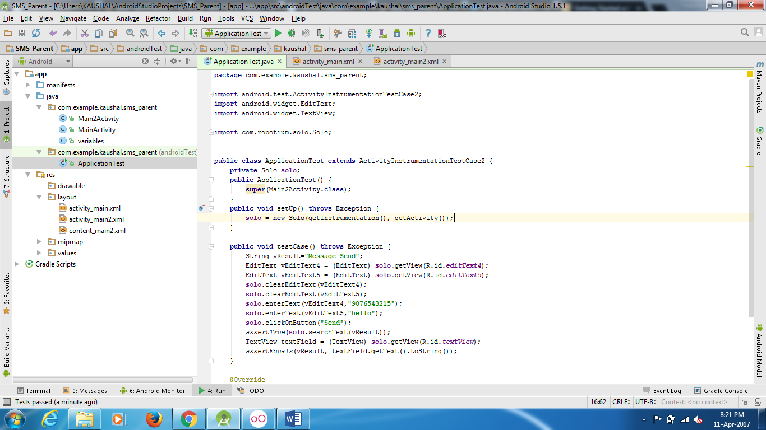

**Test Code:**

**package** com.example.kaushal.sms_parent;  
  
**import** android.test.ActivityInstrumentationTestCase2;  
**import** android.widget.EditText;  
**import** android.widget.TextView;  
  
**import** com.robotium.solo.Solo;  
  
  
**public class** ApplicationTest **extends** ActivityInstrumentationTestCase2 {  
 **private** Solo **solo**;  
 **public** ApplicationTest() {  
 **super**(Main2Activity.**class**);  
 }  
 **public void** setUp() **throws** Exception {  
 **solo** = **new** Solo(getInstrumentation(), getActivity());  
 }  
  
 **public void** testCase() **throws** Exception {  
 String vResult=**"Message Send"**;  
 EditText vEditText4 = (EditText) **solo**.getView(R.id.***editText4***);  
 EditText vEditText5 = (EditText) **solo**.getView(R.id.***editText5***);  
 **solo**.clearEditText(vEditText4);  
 **solo**.clearEditText(vEditText5);  
 **solo**.enterText(vEditText4,**"9876543215"**);  
 **solo**.enterText(vEditText5,**"hello"**);  
 **solo**.clickOnButton(**"Send"**);  
 *assertTrue*(**solo**.searchText(vResult));  
 TextView textField = (TextView) **solo**.getView(R.id.***textView***);  
 *assertEquals*(vResult, textField.getText().toString());  
 }  
  
 @Override  
 **public void** tearDown() **throws** Exception {  
 **solo**.finishOpenedActivities();  
 }  
}

**Output**

If the Tests are successful

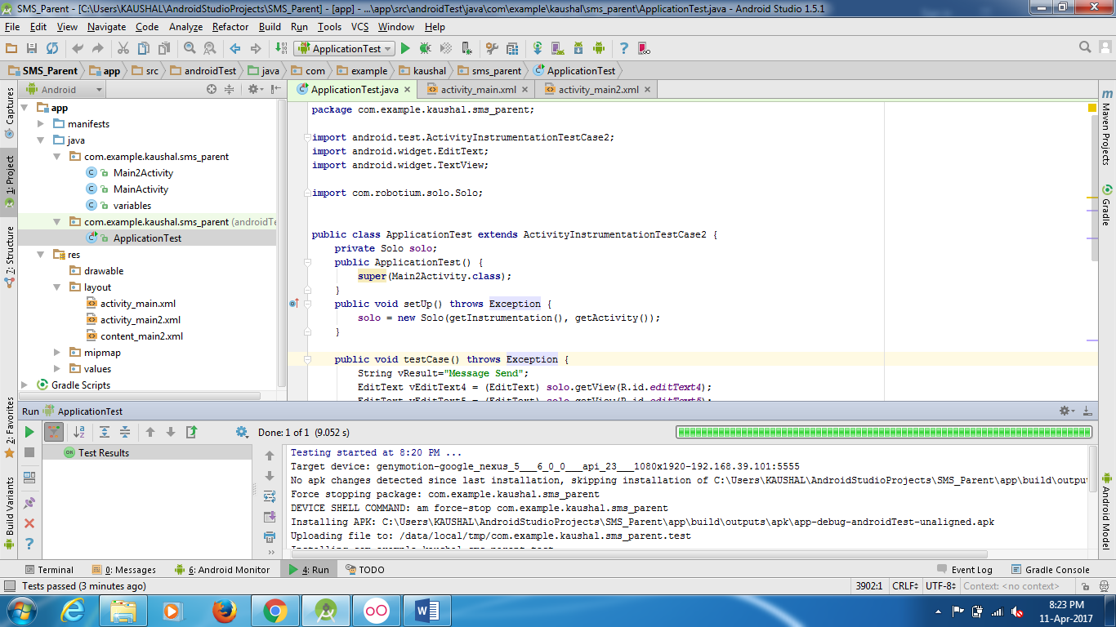

If the tests are unsuccessful

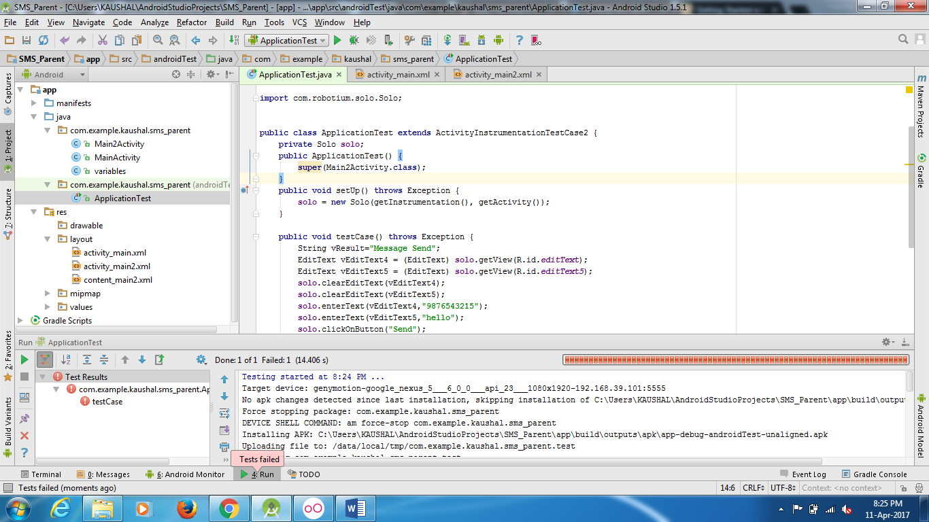

**Conclusion**

After completing this practical we are able to check any application whether it is working or not.

**Practical 2**

**Objective:** A developer develops the simple “Calculator” application - plain java application. The application has all the basic functionalities of calculator. As a JUnit Tester; write a java code to test the “Calculator” application

**Prerequisites:** Candidate should familiar with how to use controls and basic operations in android application environment.

**Steps/Process**

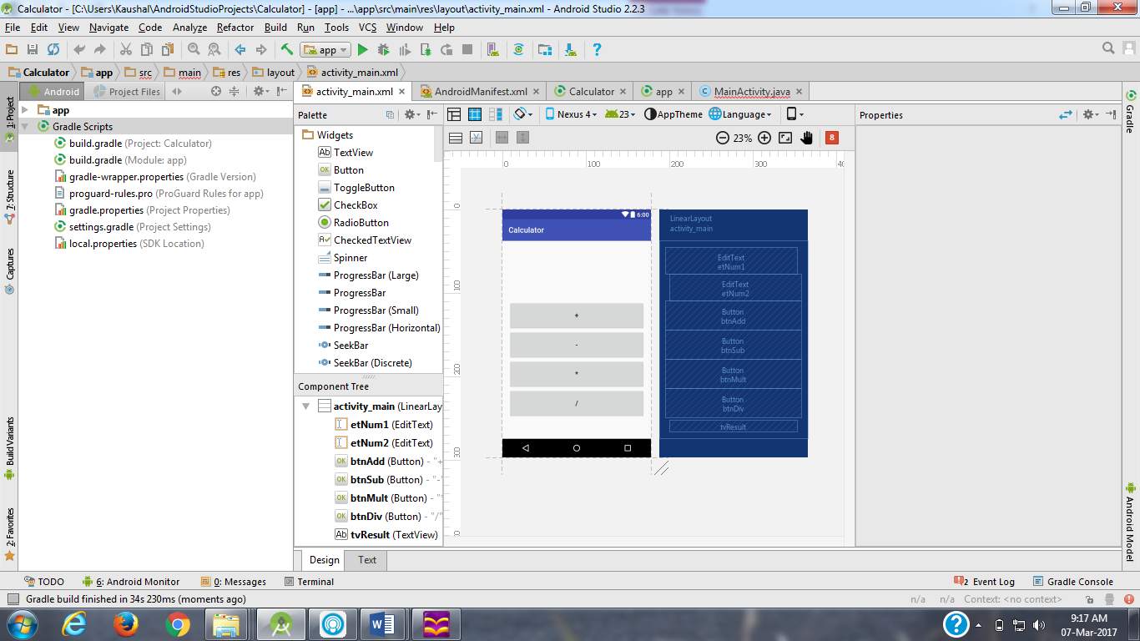

**Main Activity file (xml)**

*<?***xml version="1.0" encoding="utf-8"***?>*<**LinearLayout  
 xmlns:android="http://schemas.android.com/apk/res/android"  
 xmlns:tools="http://schemas.android.com/tools"  
 android:id="@+id/activity_main"  
 android:layout_width="fill_parent"  
 android:layout_height="fill_parent"  
 android:orientation="vertical"  
 android:paddingLeft="@dimen/activity_horizontal_margin"  
 android:paddingRight="@dimen/activity_horizontal_margin"  
 android:paddingTop="@dimen/activity_vertical_margin"  
 android:paddingBottom="@dimen/activity_vertical_margin"  
 tools:context="com.example.kaushal.calculator.MainActivity"**>  
 <**EditText  
 android:layout_weight="1"  
 android:layout_height="wrap_content"  
 android:layout_marginRight="5pt"  
 android:id="@+id/etNum1"  
 android:layout_width="match_parent"  
 android:inputType="numberDecimal"**>  
 </**EditText**>  
 <**EditText  
 android:layout_height="wrap_content"  
 android:layout_weight="1"  
 android:layout_marginLeft="5pt"  
 android:id="@+id/etNum2"  
 android:layout_width="match_parent"  
 android:inputType="numberDecimal"**>  
 </**EditText**>  
  
<**Button  
 android:layout_height="wrap_content"  
 android:layout_width="match_parent"  
 android:layout_weight="1"  
 android:text="+"  
 android:textSize="8pt"  
 android:id="@+id/btnAdd"**>  
</**Button**>  
<**Button  
 android:layout_height="wrap_content"  
 android:layout_width="match_parent"  
 android:layout_weight="1"  
 android:text="-"  
 android:textSize="8pt"  
 android:id="@+id/btnSub"**>  
</**Button**>  
<**Button  
 android:layout_height="wrap_content"  
 android:layout_width="match_parent"  
 android:layout_weight="1"  
 android:text="*"  
 android:textSize="8pt"  
 android:id="@+id/btnMult"**>  
</**Button**>  
<**Button  
 android:layout_height="wrap_content"  
 android:layout_width="match_parent"  
 android:layout_weight="1"  
 android:text="/"  
 android:textSize="8pt"  
 android:id="@+id/btnDiv"**>  
</**Button**>  
<**TextView  
android:layout_height="wrap_content"  
android:layout_width="match_parent"  
android:layout_marginLeft="5pt"  
android:layout_marginRight="5pt"  
android:textSize="12pt"  
android:layout_marginTop="3pt"  
android:id="@+id/tvResult"  
android:gravity="center_horizontal"**>  
</**TextView**>  
  
</**LinearLayout**>

**Manifest File**

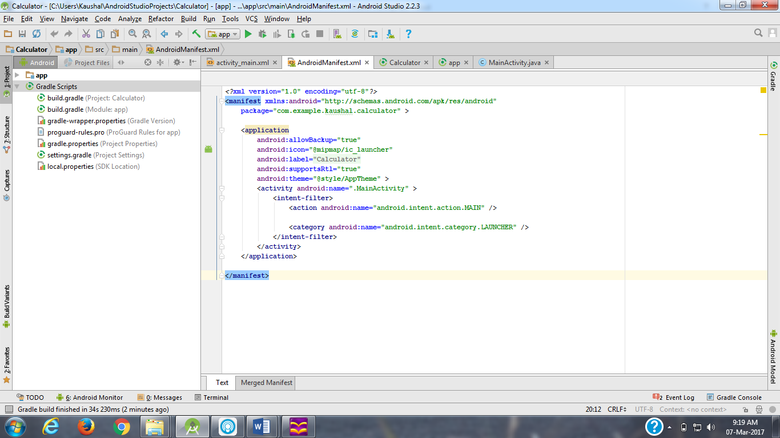

**Java File**

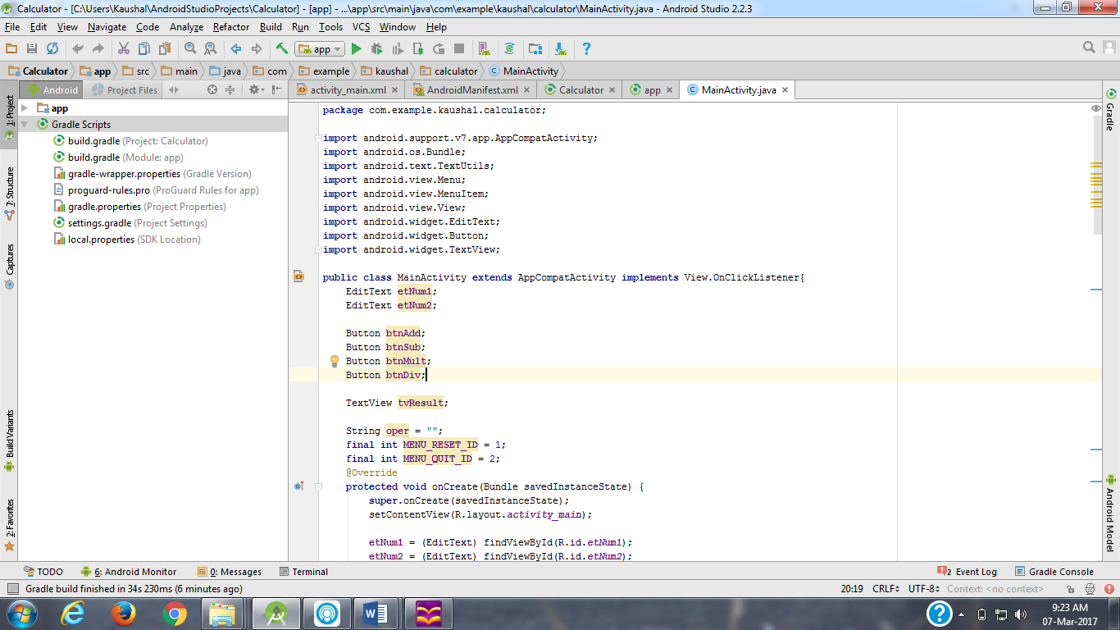

**Java Code:**

**package** com.example.kaushal.calculator;  
  
**import** android.support.v7.app.AppCompatActivity;  
**import** android.os.Bundle;  
**import** android.text.TextUtils;  
**import** android.view.Menu;  
**import** android.view.MenuItem;  
**import** android.view.View;  
**import** android.widget.EditText;  
**import** android.widget.Button;  
**import** android.widget.TextView;  
  
**public class** MainActivity **extends** AppCompatActivity{  
 EditText **etNum1**;  
 EditText **etNum2**;  
  
 Button **btnAdd**;  
 Button **btnSub**;  
 Button **btnMult**;  
 Button **btnDiv**;  
  
 **int num1**=0,**num2**=0,**num3**=0;  
  
 TextView **tvResult**;  
  
 String **oper** = **""**;  
 **final int MENU_RESET_ID** = 1;  
 **final int MENU_QUIT_ID** = 2;  
 @Override  
 **protected void** onCreate(Bundle savedInstanceState) {  
 **super**.onCreate(savedInstanceState);  
 setContentView(R.layout.***activity_main***);  
  
 **etNum1** = (EditText) findViewById(R.id.***etNum1***);  
 **etNum2** = (EditText) findViewById(R.id.***etNum2***);  
  
 **btnAdd** = (Button) findViewById(R.id.***btnAdd***);  
 **btnSub** = (Button) findViewById(R.id.***btnSub***);  
 **btnMult** = (Button) findViewById(R.id.***btnMult***);  
 **btnDiv** = (Button) findViewById(R.id.***btnDiv***);  
  
 **tvResult** = (TextView) findViewById(R.id.***tvResult***);  
  
 **num1** = Integer.*parseInt*(**etNum1**.getText().toString());  
 **num2** = Integer.*parseInt*(**etNum2**.getText().toString());  
  
 }  
 **public static int** addap(**int** a,**int** b)  
 {  
 **return** a+b;  
 }  
 **public static int** subap(**int** a,**int** b)  
 {  
 **return** a-b;  
 }  
 **public static int** multiap(**int** a,**int** b)  
 {  
 **return** a*b;  
 }  
 **public static int** divap(**int** a,**int** b)  
 {  
 **return** a/b;  
 }  
 **public void** add(View v)  
 {  
 **num3** = *addap*(**num1**,**num2**);  
 **tvResult**.setText(**num1** + **" "** + **oper** + **" "** + **num2** + **" = "** + **num3**);  
  
 }  
 **public void** sub(View v)  
 {  
 **num3** = *subap*(**num1**, **num2**);  
 **tvResult**.setText(**num1** + **" "** + **oper** + **" "** + **num2** + **" = "** + **num3**);  
 }  
 **public void** multi(View v)  
 {  
 **num3** = *multiap*(**num1**,**num2**);  
 **tvResult**.setText(**num1** + **" "** + **oper** + **" "** + **num2** + **" = "** + **num3**);  
 }  
 **public void** div(View v)  
 {  
 **num3** = *divap*(**num1**, **num2**);  
 **tvResult**.setText(**num1** + **" "** + **oper** + **" "** + **num2** + **" = "** + **num3**);  
 }  
 **public void** cleartext(View v)  
 {  
 **etNum1**.setText(0);  
 **etNum2**.setText(0);  
 **tvResult**.setText(0);  
 }  
}

**Test code File**

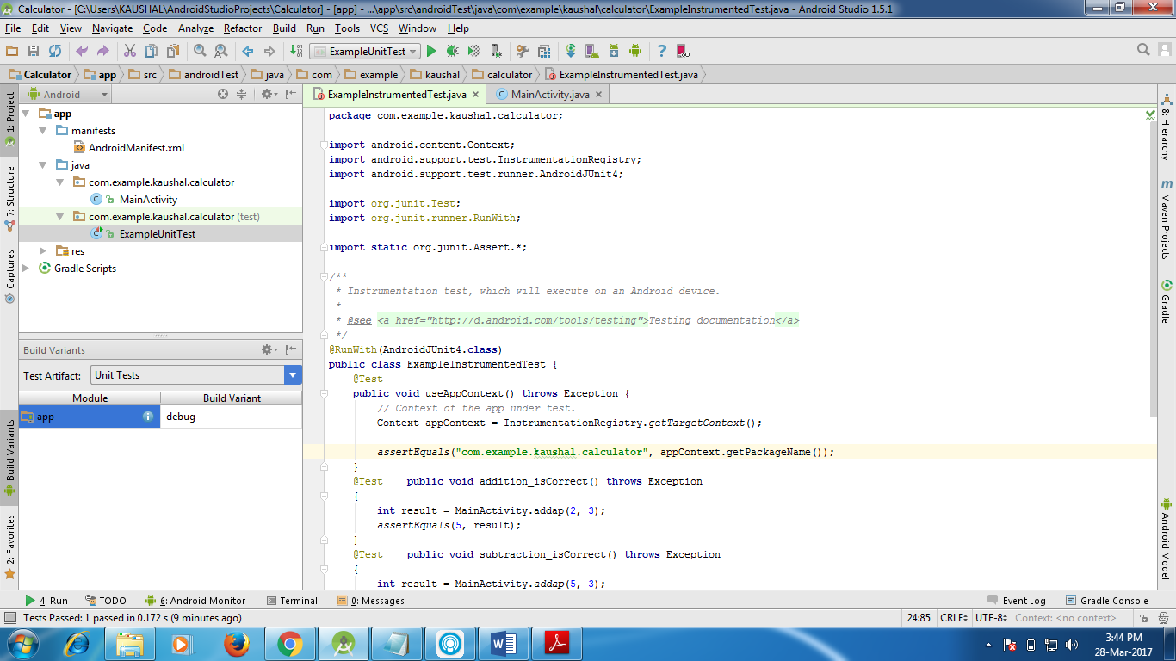

**Junit Test Code**

**package** com.example.kaushal.calculator;  
  
**import** org.junit.Test;  
  
**import static** org.junit.Assert.*;  
  
*/**  
 * Example local unit test, which will execute on the development machine (host).  
 *  
 \** ***@see*** *<a href="http://d.android.com/tools/testing">Testing documentation</a>  
 */***public class** ExampleUnitTest {  
 @Test **public void** addition_isCorrect() **throws** Exception  
 {  
 **int** result = MainActivity.*addap*(2, 3);  
 *assertEquals*(5, result);  
 }  
 @Test **public void** subtraction_isCorrect() **throws** Exception  
 {  
 **int** result = MainActivity.*addap*(5, 3);  
 *assertEquals*(2, result);  
 }  
 @Test **public void** multiplication_isCorrect() **throws** Exception  
 {  
 **int** result = MainActivity.*addap*(2,3);  
 *assertEquals*(6, result);  
 }  
 @Test **public void** division_isCorrect() **throws** Exception  
 {  
 **int** result = MainActivity.*addap*(5,3);  
 *assertEquals*(1, result);  
 }  
  
}

**Output**

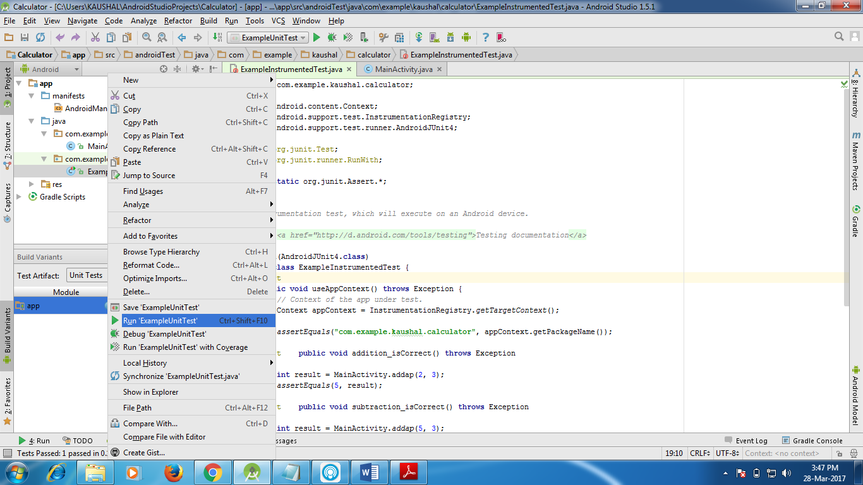

If the Tests are successful

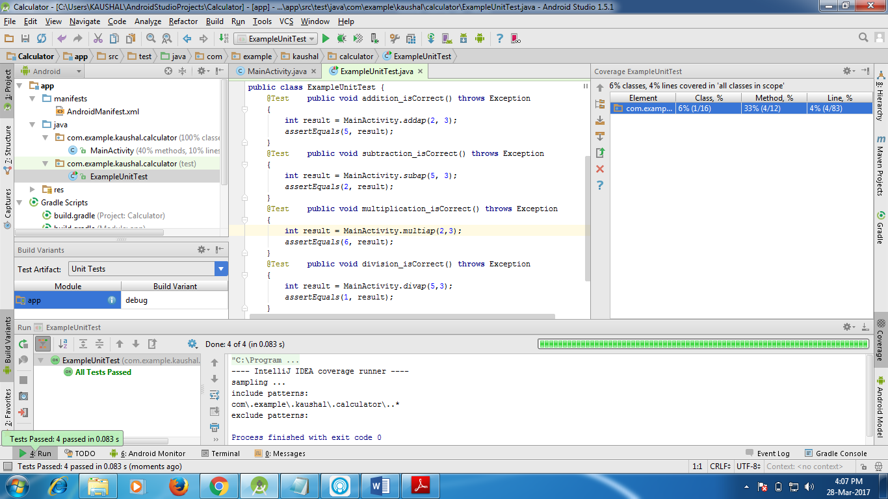

If the Tests are unsuccessful

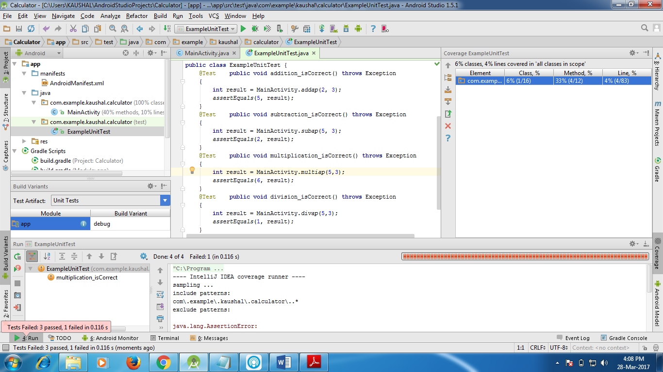

**Conclusion**

After completing this practical we are able to check any application whether it is working or not.

**Practical 3**

**Objective:** Write a java code to test “Activity” using Android Testing Framework.

Given: “Login App”

**Prerequisites:** Candidate should familiar with how to use controls and basic operations in android application environment.

**Steps/Process**

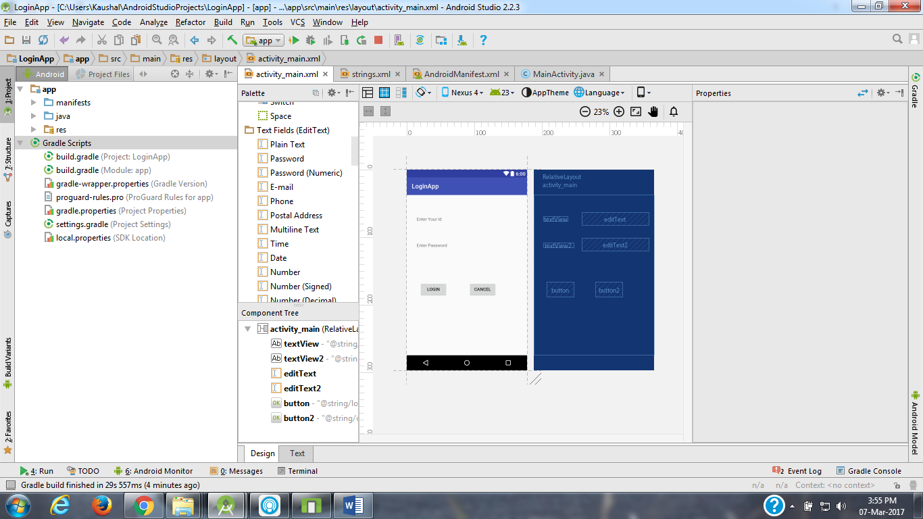

**Main Activity file (xml)**

*<?***xml version="1.0" encoding="utf-8"***?>*<**RelativeLayout xmlns:android="http://schemas.android.com/apk/res/android"  
 xmlns:tools="http://schemas.android.com/tools"  
 android:id="@+id/activity_main"  
 android:layout_width="match_parent"  
 android:layout_height="match_parent"  
 android:paddingBottom="@dimen/activity_vertical_margin"  
 android:paddingLeft="@dimen/activity_horizontal_margin"  
 android:paddingRight="@dimen/activity_horizontal_margin"  
 android:paddingTop="@dimen/activity_vertical_margin"  
 tools:context="com.example.kaushal.loginapp.MainActivity"**>  
  
 <**TextView  
 android:text="@string/enter_your_id"  
 android:layout_width="wrap_content"  
 android:layout_height="wrap_content"  
 android:layout_alignParentTop="true"  
 android:layout_alignParentStart="true"  
 android:layout_marginStart="16dp"  
 android:layout_marginTop="53dp"  
 android:id="@+id/textView"** />  
  
 <**TextView  
 android:text="@string/enter_password"  
 android:layout_width="wrap_content"  
 android:layout_height="wrap_content"  
 android:layout_below="@+id/textView"  
 android:layout_alignStart="@+id/textView"  
 android:layout_marginTop="67dp"  
 android:id="@+id/textView2"** />  
  
 <**EditText  
 android:layout_width="wrap_content"  
 android:layout_height="wrap_content"  
 android:inputType="textPersonName"  
 android:ems="10"  
 android:id="@+id/editText"  
 android:layout_alignBaseline="@+id/textView"  
 android:layout_alignBottom="@+id/textView"  
 android:layout_alignParentEnd="true"  
 tools:ignore="LabelFor,RelativeOverlap"** />  
  
 <**EditText  
 android:layout_width="wrap_content"  
 android:layout_height="wrap_content"  
 android:inputType="textPassword"  
 android:ems="10"  
 android:layout_below="@+id/editText"  
 android:layout_alignStart="@+id/editText"  
 android:layout_marginTop="40dp"  
 android:id="@+id/editText2"  
 tools:ignore="LabelFor"** />  
  
 <**Button  
 android:text="@string/login"  
 android:layout_width="wrap_content"  
 android:layout_height="wrap_content"  
 android:layout_below="@+id/editText2"  
 android:layout_alignEnd="@+id/textView2"  
 android:layout_marginTop="97dp"  
 android:id="@+id/button"  
 android:onClick="loginbutton"** />  
  
 <**Button  
 android:text="@string/cancel"  
 android:layout_width="wrap_content"  
 android:layout_height="wrap_content"  
 android:layout_alignBottom="@+id/button"  
 android:layout_alignStart="@+id/editText2"  
 android:layout_marginStart="45dp"  
 android:id="@+id/button2"  
 android:onClick="cancelbutton"** />  
  
</**RelativeLayout**>

**Manifest File**

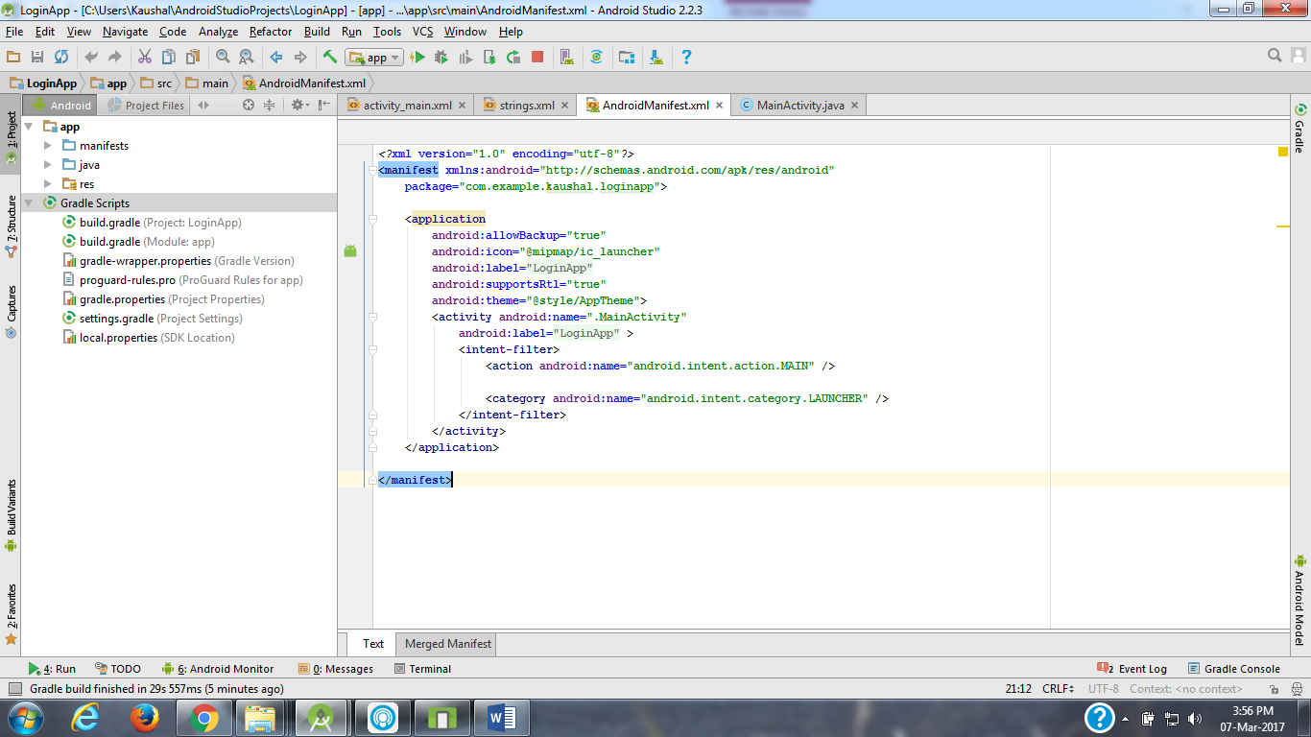

**Java File**

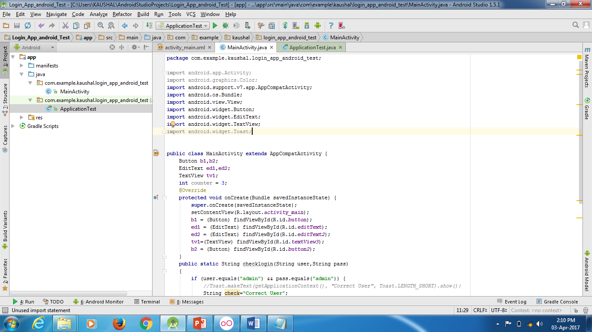

**Java Code:**

**package** com.example.kaushal.login_app_android_test;  
  
**import** android.app.Activity;  
**import** android.graphics.Color;  
**import** android.support.v7.app.AppCompatActivity;  
**import** android.os.Bundle;  
**import** android.view.View;  
**import** android.widget.Button;  
**import** android.widget.EditText;  
**import** android.widget.TextView;  
**import** android.widget.Toast;  
  
  
**public class** MainActivity **extends** AppCompatActivity {  
 Button **b1**,**b2**;  
 EditText **ed1**,**ed2**;  
 TextView **tv1**;  
 **int counter** = 3;  
 @Override  
 **protected void** onCreate(Bundle savedInstanceState) {  
 **super**.onCreate(savedInstanceState);  
 setContentView(R.layout.***activity_main***);  
 **b1** = (Button) findViewById(R.id.***button***);  
 **ed1** = (EditText) findViewById(R.id.***editText***);  
 **ed2** = (EditText) findViewById(R.id.***editText2***);  
 **tv1**=(TextView) findViewById(R.id.***textView3***);  
 **b2** = (Button) findViewById(R.id.***button2***);  
 }  
 **public static** String checklogin(String user,String pass)  
 {  
 **if** (user.equals(**"admin"**) && pass.equals(**"admin"**)) {  
 *//Toast.makeText(getApplicationContext(), "Correct User", Toast.LENGTH_SHORT).show();* String check=**"Correct User"**;  
 **return** check;  
 } **else** {  
 *//Toast.makeText(getApplicationContext(), "Wrong Credentials", Toast.LENGTH_SHORT).show();* String check=**"InCorrect User"**;  
 **return** check;  
 }  
 }  
 **public void** loginbutton(View v)  
 {  
 String name = **ed1**.getText().toString();  
 String pass = **ed2**.getText().toString();  
 String checkuser=*checklogin*(name,pass);  
 **tv1**.setText(checkuser);  
 }  
 **public void** cancelbutton(View v)  
 {  
 finish();  
 }  
}

**Test File Code:**

**package** com.example.kaushal.login_app_android_test;  
  
**import** android.app.Application;  
**import** android.test.ApplicationTestCase;  
  
**public class** ApplicationTest **extends** ApplicationTestCase<Application> {  
 **public** ApplicationTest() {  
 **super**(Application.**class**);  
 }  
 **public void** login_correct() **throws** Exception  
 {  
 String result = MainActivity.*checklogin*(**"admin"**,**"admin"**);  
 *assertEquals*(**"Correct User"**, result);  
 }  
  
}

**dependencies**

apply plugin: **'com.android.application'**android {  
 compileSdkVersion 23  
 buildToolsVersion **"25.0.1"** defaultConfig {  
 applicationId **"com.example.kaushal.login_app_android_test"** minSdkVersion 19  
 targetSdkVersion 23  
 versionCode 1  
 versionName **"1.0"** }  
 buildTypes {  
 release {  
 minifyEnabled **false** proguardFiles getDefaultProguardFile(**'proguard-android.txt'**), **'proguard-rules.pro'** }  
 }  
}  
  
dependencies {  
 compile fileTree(dir: **'libs'**, include: [**'*.jar'**])  
 testCompile **'junit:junit:4.12'** compile **'com.android.support:appcompat-v7:23.4.0'**}

**Output**

If the tests are successful

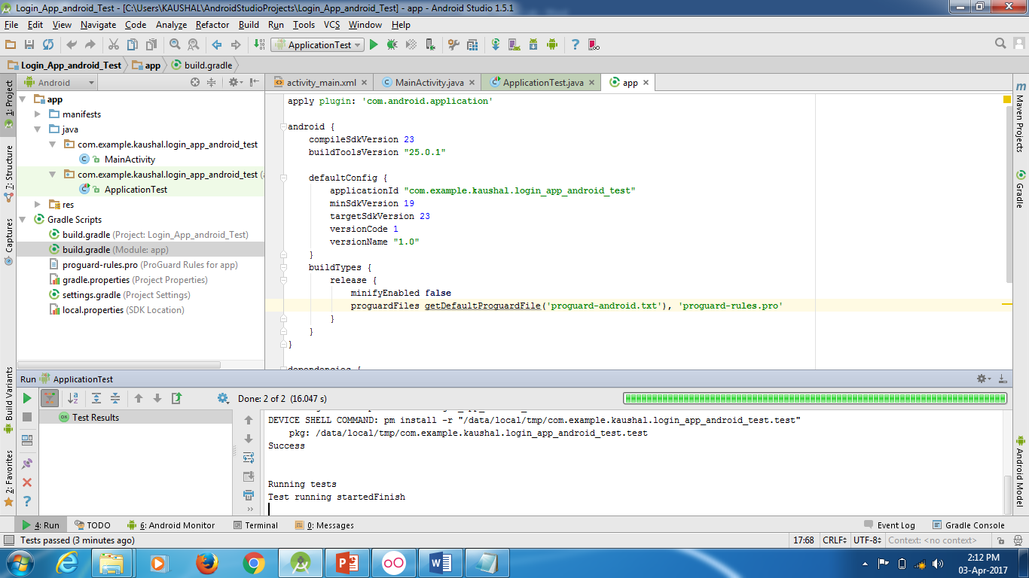

If the tests are unsuccessful

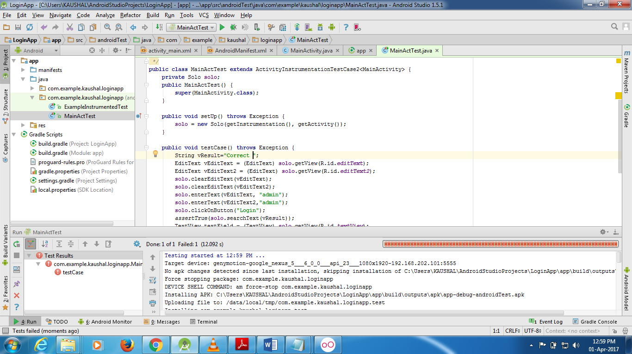

**Conclusion**

After completing this practical we are able to check username and password and test the app.

**Practical 4**

**Objective:** Write a code to test “Activity” using Robotium Framework.

Given: “Login App”

**Prerequisites:** Candidate should familiar with how to use controls and basic operations in android application environment.

**Steps/Process**

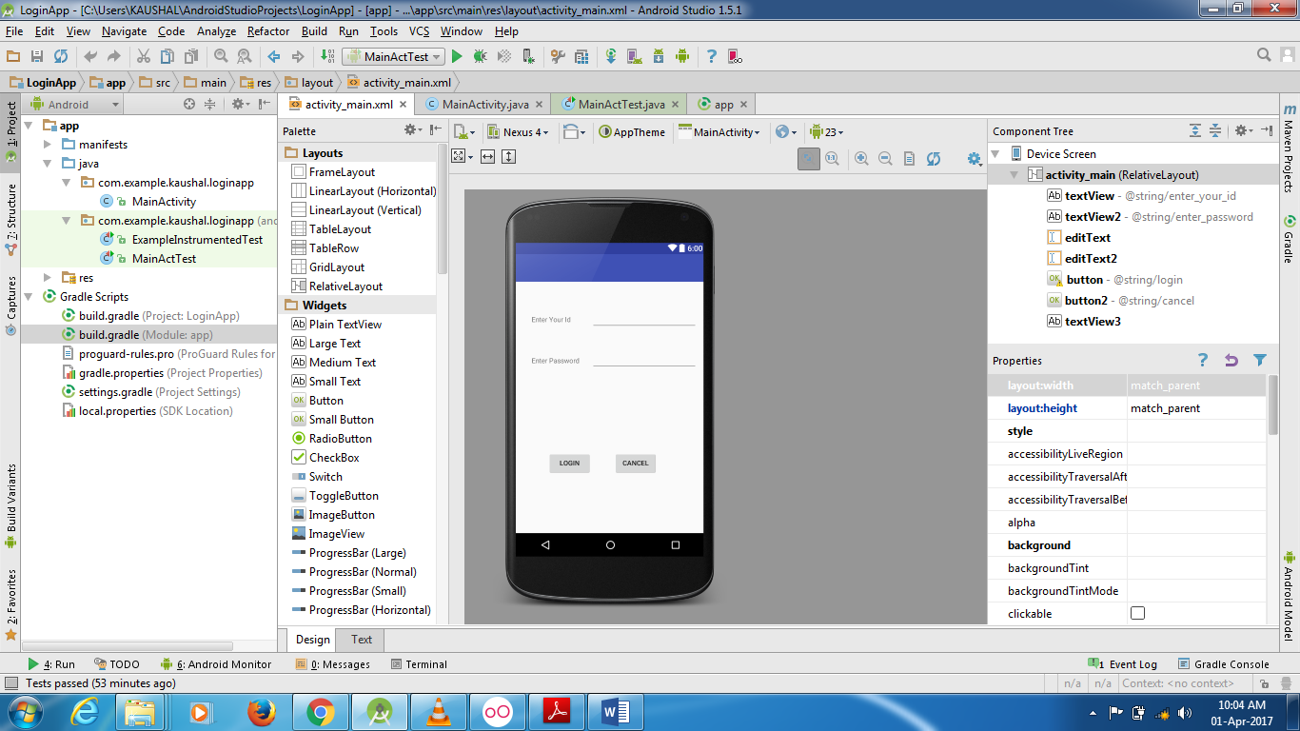

**Main Activity file (xml)**

*<?***xml version="1.0" encoding="utf-8"***?>*<**RelativeLayout xmlns:android="http://schemas.android.com/apk/res/android"  
 xmlns:tools="http://schemas.android.com/tools"  
 android:id="@+id/activity_main"  
 android:layout_width="match_parent"  
 android:layout_height="match_parent"  
 android:paddingBottom="@dimen/activity_vertical_margin"  
 android:paddingLeft="@dimen/activity_horizontal_margin"  
 android:paddingRight="@dimen/activity_horizontal_margin"  
 android:paddingTop="@dimen/activity_vertical_margin"  
 tools:context="com.example.kaushal.loginapp.MainActivity"**>  
  
 <**TextView  
 android:text="@string/enter_your_id"  
 android:layout_width="wrap_content"  
 android:layout_height="wrap_content"  
 android:layout_alignParentTop="true"  
 android:layout_alignParentStart="true"  
 android:layout_marginStart="16dp"  
 android:layout_marginTop="53dp"  
 android:id="@+id/textView"** />  
  
 <**TextView  
 android:text="@string/enter_password"  
 android:layout_width="wrap_content"  
 android:layout_height="wrap_content"  
 android:layout_below="@+id/textView"  
 android:layout_alignStart="@+id/textView"  
 android:layout_marginTop="67dp"  
 android:id="@+id/textView2"** />  
  
 <**EditText  
 android:layout_width="wrap_content"  
 android:layout_height="wrap_content"  
 android:inputType="textPersonName"  
 android:ems="10"  
 android:id="@+id/editText"  
 android:layout_alignBaseline="@+id/textView"  
 android:layout_alignBottom="@+id/textView"  
 android:layout_alignParentEnd="true"  
 tools:ignore="LabelFor,RelativeOverlap"** />  
  
 <**EditText  
 android:layout_width="wrap_content"  
 android:layout_height="wrap_content"  
 android:inputType="textPassword"  
 android:ems="10"  
 android:layout_below="@+id/editText"  
 android:layout_alignStart="@+id/editText"  
 android:layout_marginTop="40dp"  
 android:id="@+id/editText2"  
 tools:ignore="LabelFor"** />  
  
 <**Button  
 android:text="@string/login"  
 android:layout_width="wrap_content"  
 android:layout_height="wrap_content"  
 android:id="@+id/button"  
 android:onClick="loginbutton"  
 android:layout_marginLeft="24dp"  
 android:layout_alignTop="@+id/button2"  
 android:layout_toStartOf="@+id/editText2"** />  
  
 <**Button  
 android:text="@string/cancel"  
 android:layout_width="wrap_content"  
 android:layout_height="wrap_content"  
 android:layout_marginStart="46dp"  
 android:id="@+id/button2"  
 android:onClick="cancelbutton"  
 android:layout_alignParentBottom="true"  
 android:layout_alignStart="@+id/editText2"  
 android:layout_marginBottom="102dp"** />  
  
 <**TextView  
 android:layout_width="wrap_content"  
 android:layout_height="wrap_content"  
 android:id="@+id/textView3"  
 android:layout_centerVertical="true"  
 android:layout_alignStart="@+id/button"  
 android:width="200dp"  
 android:height="50dp"** />  
  
</**RelativeLayout**>

**Manifest File**

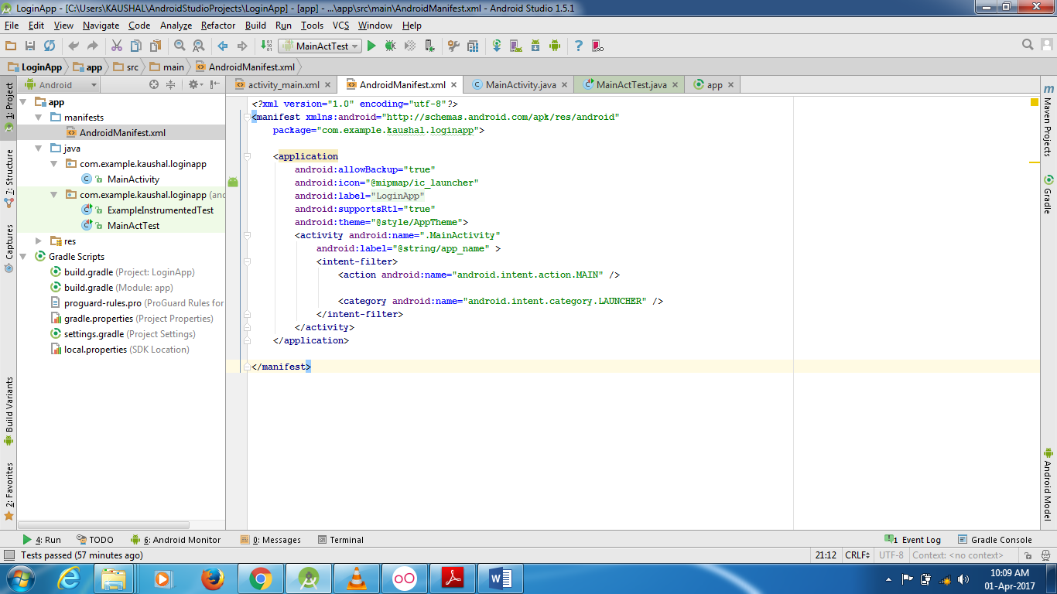

**Java File**

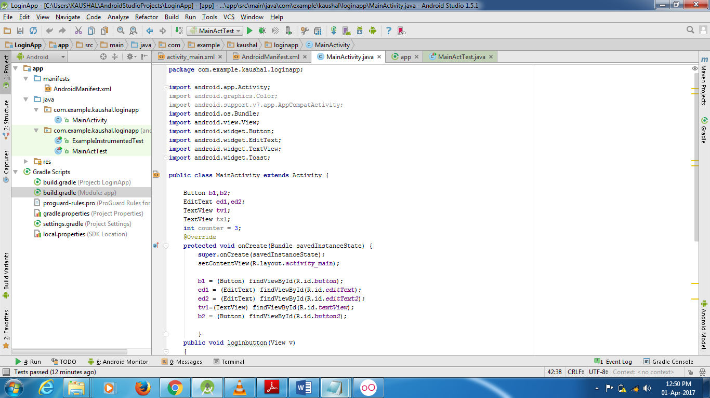

**Java Code:**

**package** com.example.kaushal.loginapp;

**import** android.app.Activity;

**import** android.graphics.Color;

**import** android.support.v7.app.AppCompatActivity;

**import** android.os.Bundle;

**import** android.view.View;

**import** android.widget.Button;

**import** android.widget.EditText;

**import** android.widget.TextView;

**import** android.widget.Toast;

**public class** MainActivity **extends** Activity {

Button **b1**,**b2**;

EditText **ed1**,**ed2**;

TextView **tv1**;

TextView **tx1**;

**int counter** = 3;

@Override

**protected void** onCreate(Bundle savedInstanceState) {

**super**.onCreate(savedInstanceState);

setContentView(R.layout.***activity_main***);

**b1** = (Button) findViewById(R.id.***button***);

**ed1** = (EditText) findViewById(R.id.***editText***);

**ed2** = (EditText) findViewById(R.id.***editText2***);

**tv1**=(TextView) findViewById(R.id.***textView***);

**b2** = (Button) findViewById(R.id.***button2***);

}

**public void** loginbutton(View v)

{

String name = **ed1**.getText().toString();

String uname = String.*format*(**"%s"**, name);

String pass = **ed2**.getText().toString();

String upass = String.*format*(**"%s"**, pass);

**if** (uname.equals(**"admin"**) && upass.equals(**"admin"**)) {

Toast.*makeText*(getApplicationContext(),

**"Correct User"**, Toast.***LENGTH_SHORT***).show();

**tv1**.setText(**"Correct User"**);

} **else** {

Toast.*makeText*(getApplicationContext(), **"Wrong Credentials"**, Toast.***LENGTH_SHORT***).show();

**tv1**.setText(**"InCorrect User"**);

}

}

**public void** cancelbutton(View v)

{

finish();

}

}

**Install Android images and tools.**

Click on SDK Manager – and install

* Intel x86 Atom System Image
* Intel x64 Atom System Image

For all operating systems.

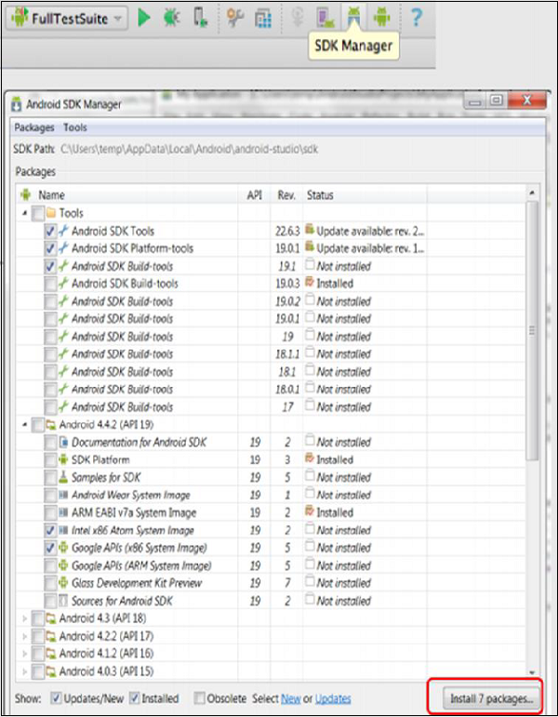

**Test File Code**

1. In the java folder, in androidTest Package, create another androidTest java class and add this code.
2. Add the file here as this picture shows.

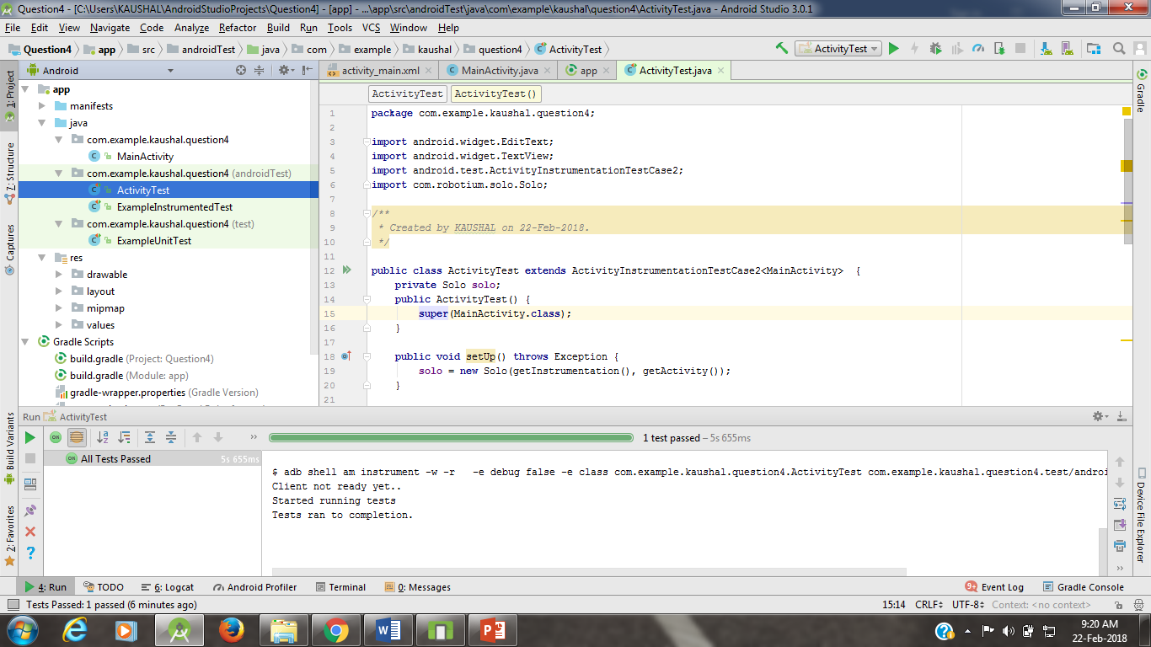

**package** com.example.kaushal.loginapp;

**import** com.robotium.solo.Solo;

**import** android.test.ActivityInstrumentationTestCase2;

**import** android.widget.EditText;

**import** android.widget.TextView;

**public class** ActivityTest **extends** ActivityInstrumentationTestCase2<MainActivity> {

**private** Solo **solo**;

**public** ActivityTest () {

**super**(MainActivity.**class**);

}

**public void** setUp() **throws** Exception {

**solo** = **new** Solo(getInstrumentation(), getActivity());

}

**public void** testCase() **throws** Exception {

String vResult=**"Correct User"**;

EditText vEditText = (EditText) **solo**.getView(R.id.***editText***);

EditText vEditText2 = (EditText) **solo**.getView(R.id.***editText2***);

**solo**.clearEditText(vEditText);

**solo**.clearEditText(vEditText2);

**solo**.enterText(vEditText, **"admin"**);

**solo**.enterText(vEditText2,**"admin"**);

**solo**.clickOnButton(**"Login"**);

*assertTrue*(**solo**.searchText(vResult));

TextView textField = (TextView) **solo**.getView(R.id.***textView***);

*//Assert to verify result with visible value*

*assertEquals*(vResult, textField.getText().toString());

}

@Override

**public void** tearDown() **throws** Exception {

**solo**.finishOpenedActivities();

}

}

Download and add Robotium.jar file

**Dependencies**

apply plugin: **'com.android.application'**

android {

compileSdkVersion 23

buildToolsVersion **"25.0.1"**

defaultConfig {

applicationId **"com.example.kaushal.loginapp"**

minSdkVersion 19

targetSdkVersion 23

versionCode 1

versionName **"1.0"**

testInstrumentationRunner **"android.support.test.runner.AndroidJUnitRunner"**

}

buildTypes {

release {

minifyEnabled **false**

proguardFiles getDefaultProguardFile(**'proguard-android.txt'**), **'proguard-rules.pro'**

}

}

}

dependencies {

androidTestCompile **'com.jayway.android.robotium:robotium-solo:5.6.3'**

compile fileTree(dir: **'libs'**, include: [**'*.jar'**])

androidTestCompile(**'com.android.support.test.espresso:espresso-core:2.2.2'**, {

exclude group: **'com.android.support'**, module: **'support-annotations'**

})

compile **'com.android.support:appcompat-v7:23.4.0'**

testCompile **'junit:junit:4.12'**

}

**Output**

If the tests are successful

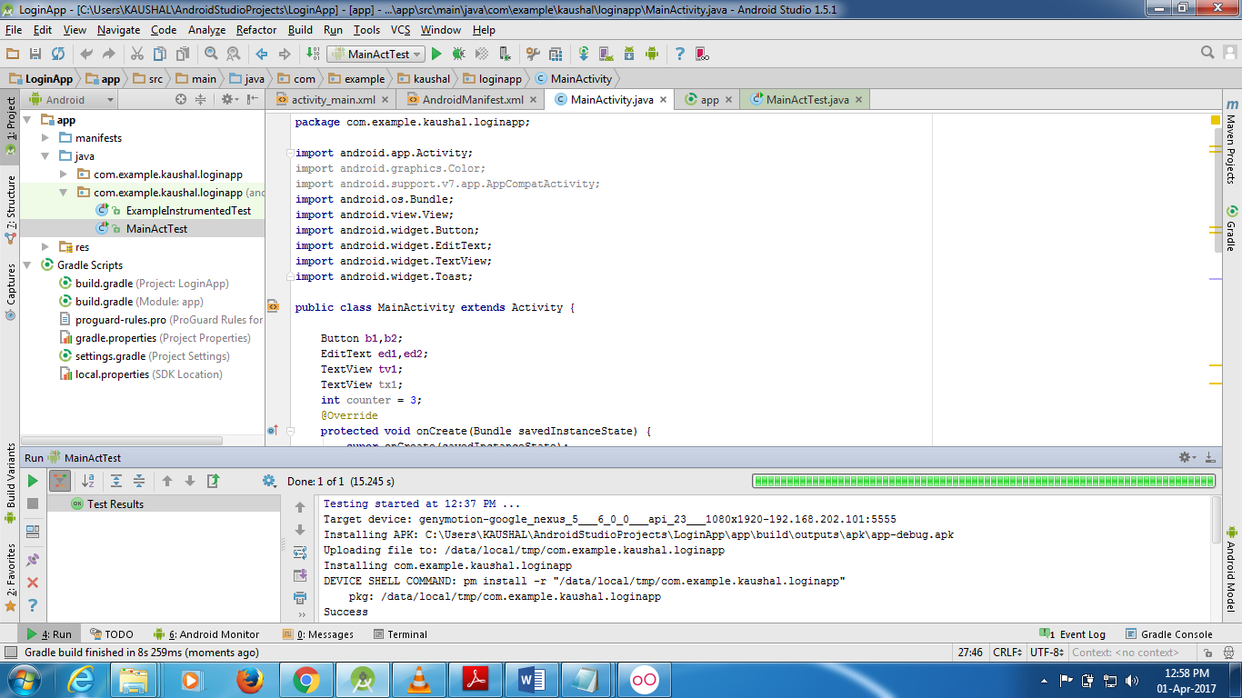

If the tests are unsuccessful



**Conclusion**

After completing this practical we are able to check any application whether it is working or not.

**Practical 5**

**Objective:** Write a code to test “Service” using Android Testing Framework.

Given: “Service App”

**Prerequisites:** Candidate should familiar with how to use controls and basic operations in android application environment.

**Steps/Process**

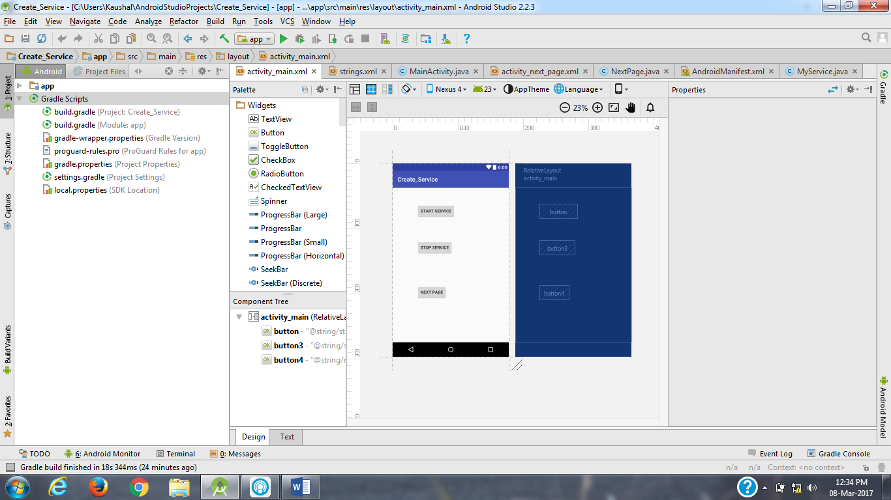

**Main Activity file (xml)**

*<?***xml version="1.0" encoding="utf-8"***?>*<**RelativeLayout xmlns:android="http://schemas.android.com/apk/res/android"  
 xmlns:tools="http://schemas.android.com/tools"  
 android:id="@+id/activity_main"  
 android:layout_width="match_parent"  
 android:layout_height="match_parent"  
 android:paddingBottom="@dimen/activity_vertical_margin"  
 android:paddingLeft="@dimen/activity_horizontal_margin"  
 android:paddingRight="@dimen/activity_horizontal_margin"  
 android:paddingTop="@dimen/activity_vertical_margin"  
 tools:context="com.example.kaushal.create_service.MainActivity"**>  
  
 <**Button  
 android:text="@string/start_service"  
 android:layout_width="wrap_content"  
 android:layout_height="wrap_content"  
 android:layout_alignParentTop="true"  
 android:layout_alignParentStart="true"  
 android:layout_marginStart="64dp"  
 android:layout_marginTop="37dp"  
 android:id="@+id/button"  
 android:onClick="startService"** />  
  
 <**Button  
 android:text="@string/stop_service"  
 android:layout_width="wrap_content"  
 android:layout_height="wrap_content"  
 android:layout_marginTop="73dp"  
 android:id="@+id/button3"  
 android:layout_below="@+id/button"  
 android:layout_alignStart="@+id/button"  
 android:onClick="stopService"** />  
  
 <**Button  
 android:text="@string/next_page"  
 android:layout_width="wrap_content"  
 android:layout_height="wrap_content"  
 android:layout_marginTop="100dp"  
 android:id="@+id/button4"  
 android:onClick="nextpage"  
 android:layout_below="@+id/button3"  
 android:layout_alignStart="@+id/button3"** />  
</**RelativeLayout**>

**Manifest File**

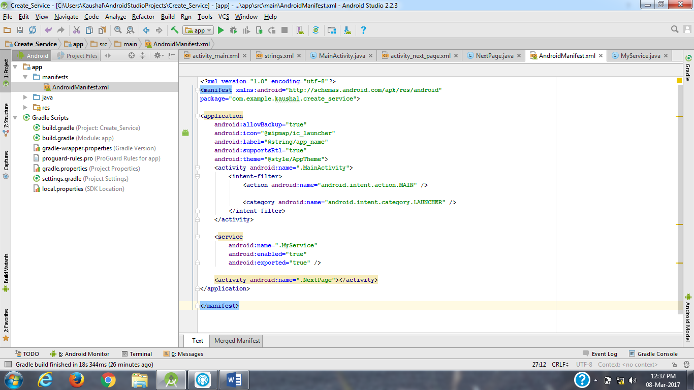

**Java File**

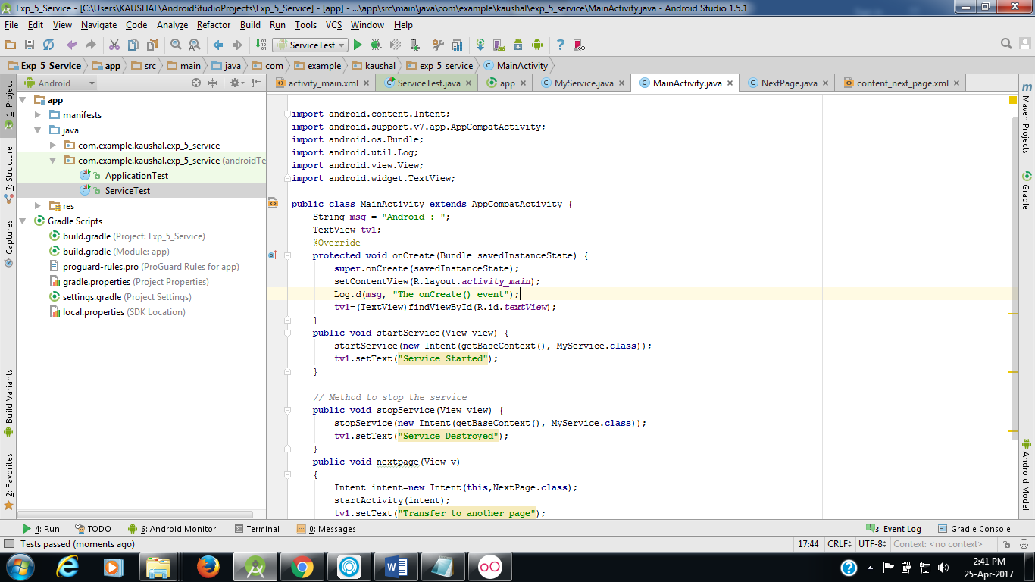

**Java Code:**

**package** com.example.kaushal.create_service;  
  
**import** android.support.v7.app.AppCompatActivity;  
**import** android.os.Bundle;  
**import** android.view.View;  
**import** android.content.Intent;  
**import** android.app.Activity;  
**import** android.util.Log;  
**import** android.view.View;  
  
**public class** MainActivity **extends** Activity {  
 String **msg** = **"Android : "**;  
 @Override  
 **public void** onCreate(Bundle savedInstanceState) {  
 **super**.onCreate(savedInstanceState);  
 setContentView(R.layout.***activity_main***);  
 Log.*d*(**msg**, **"The onCreate() event"**);  
 }  
  
 **public void** startService(View view) {  
 startService(**new** Intent(getBaseContext(), MyService.**class**));  
 }  
  
 *// Method to stop the service* **public void** stopService(View view) {  
 stopService(**new** Intent(getBaseContext(), MyService.**class**));  
 }  
 **public void** nextpage(View v)  
 {  
 Intent intent=**new** Intent(**this**,NextPage.**class**);  
 startActivity(intent);  
 }  
}

**Service Class:**

**package** com.example.kaushal.exp_5_service;  
  
**import** android.app.Service;  
**import** android.content.Intent;  
**import** android.os.IBinder;  
**import** android.widget.Toast;  
  
**public class** MyService **extends** Service {  
 **public** MyService() {  
 }  
  
 @Override  
 **public** IBinder onBind(Intent intent) {  
 *//* ***TODO: Return the communication channel to the service.* throw new** UnsupportedOperationException(**"Not yet implemented"**);  
 }  
 @Override  
 **public int** onStartCommand(Intent intent, **int** flags, **int** startId) {  
 *// Let it continue running until it is stopped.* Toast.*makeText*(**this**, **"Service Started"**, Toast.***LENGTH_LONG***).show();  
 **return *START_STICKY***;  
 }  
  
 @Override  
 **public void** onDestroy() {  
 **super**.onDestroy();  
 Toast.*makeText*(**this**, **"Service Destroyed"**, Toast.***LENGTH_LONG***).show();  
 }  
}

**NextPage**

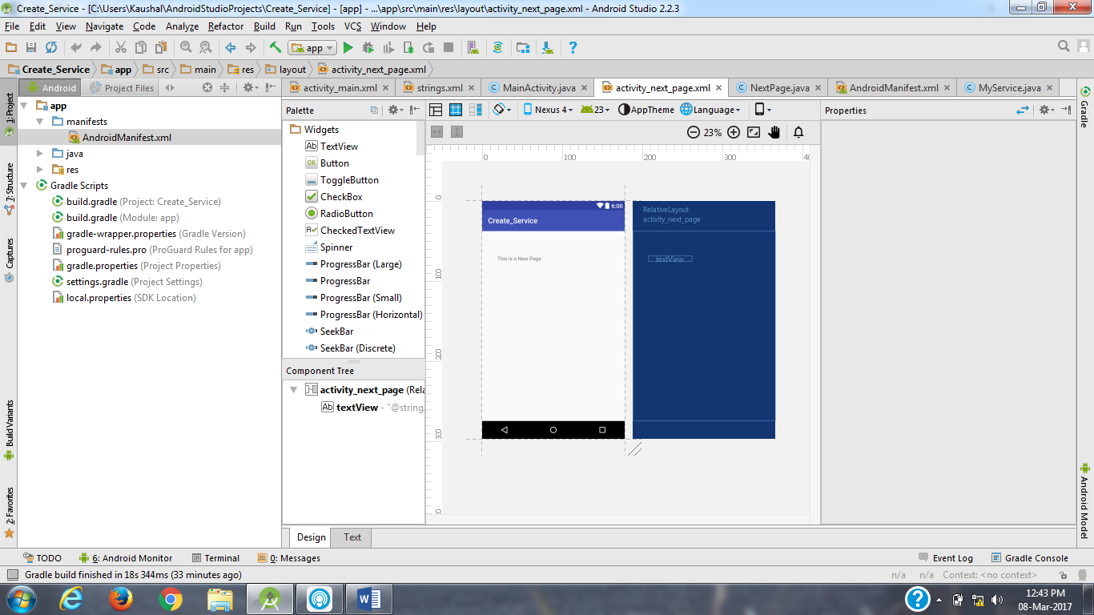

**Test File Code**

**package** com.example.kaushal.exp_5_service;  
  
**import** android.test.ActivityInstrumentationTestCase2;  
**import** android.widget.TextView;  
**import** com.robotium.solo.Solo;  
  
**public class** ServiceTest **extends** ActivityInstrumentationTestCase2<MainActivity> {  
 **private** Solo **solo**;  
 **public** ServiceTest() {  
 **super**(MainActivity.**class**);  
 }  
 **public void** setUp() **throws** Exception {  
 **solo** = **new** Solo(getInstrumentation(), getActivity());  
 }  
  
 **public void** testCase() **throws** Exception {  
 String vResult=**"Service Started"**;  
 String vResult1=**"Service Destroyed"**;  
 String vResult2=**"Transfer to another page"**;  
 **solo**.clickOnButton(**"Start Service"**);  
 *assertTrue*(**solo**.searchText(vResult));  
 TextView textField = (TextView) **solo**.getView(R.id.***textView***);  
 *//Assert to verify result with visible value  
 assertEquals*(vResult, textField.getText().toString());  
 }  
  
 @Override  
 **public void** tearDown() **throws** Exception {  
 **solo**.finishOpenedActivities();  
 }  
}

Download and add Robotium.jar file

**Dependencies**

apply plugin: **'com.android.application'**android {  
 compileSdkVersion 23  
 buildToolsVersion **"25.0.1"** defaultConfig {  
 applicationId **"com.example.kaushal.exp_5_service"** minSdkVersion 19  
 targetSdkVersion 23  
 versionCode 1  
 versionName **"1.0"** }  
 buildTypes {  
 release {  
 minifyEnabled **false** proguardFiles getDefaultProguardFile(**'proguard-android.txt'**), **'proguard-rules.pro'** }  
 }  
}  
  
dependencies {  
  
 androidTestCompile **'com.jayway.android.robotium:robotium-solo:5.6.3'** compile fileTree(dir: **'libs'**, include: [**'*.jar'**])  
 testCompile **'junit:junit:4.12'** compile **'com.android.support:appcompat-v7:23.4.0'** compile **'com.android.support:design:23.4.0'**}

**Output**

If the tests are successful

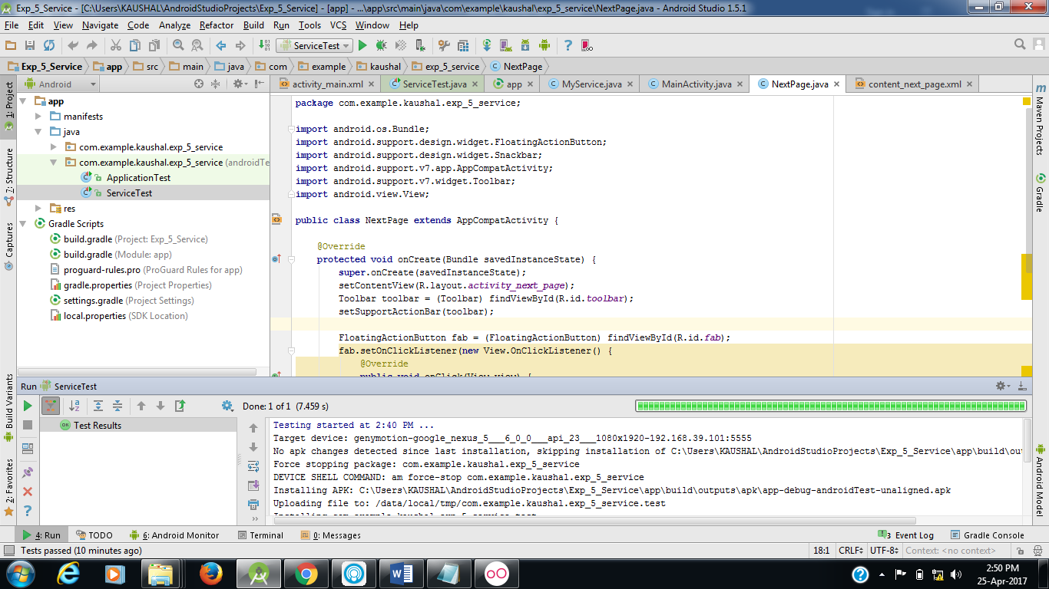

If the tests are unsuccessful

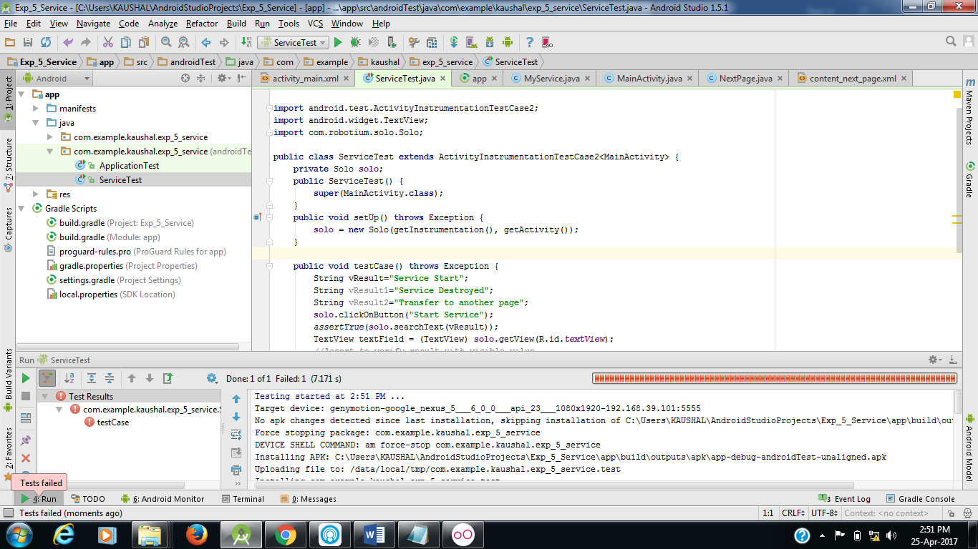

**Conclusion**

After completing this practical we are able to create a service and check whether it is working or not.